**SAMPURN**

A Comprehensive Solution for Food & Nutrition Tracking

Project Report

**BCIS 5140 AI FOR BUSINESS**



**GROUP: TEAM 08**

Sritha Darbha

Sonika Singh Thakur

Sai Teja Reddy Jillella

**Table of Contents**

Executive Summary03

Industry Description04

Problem Description05

Solution Description06

Solution Data Requirements07

Acquisition strategy/Platform Requirements08

AI Cloud API’s 08

Proprietary Algorithm08

Custom Algorithm 09

ML Model Requirements09

MI Based Model09

Role of the Model09

Performance Criteria09

Solution Architecture10

Solution Architecture10

Code11

Model Summary14

Prototype14

Prototype Live Link14

References/Citations 18

**Executive Summary**

One of the good outcomes of COVID has been that it has nudged people throughout the world to actively take care of their health – both mental and physical. We live in an era where mobile devices and fitness trackers are not seen any different from limbs. With AI and ML being incorporated in our daily lives in every aspect, we at Sampurn aim at building a comprehensive end to end solution to Healthcare – Food and fitness tracking; a one-stop shop of sorts, based on the goal entered initially and every use case, the user takes a picture of their food, enters information about where he ordered from, clicks a picture of their pantry for recipe recommendations, or manually enters the portion and components of their meal, finally obtaining dynamic personalized insights based on their conditions and activity. The rewarding opportunity, blueprint of our proposed solution and future business prospects have been discussed further in the report.

After being reluctant for a long time, the Healthcare sector has slowly begun accepting technology to improve itself. Owing to this, there has been an advent in mobile applications competing for market share in the healthcare sector. Currently, the value of mHealth app market is close to USD 38.2 billion with an estimated CAGR of 11.8% from 2022 to 2030 (Grand View Research, n.d.). Thorough research and market analysis exposes a lot of gaps in implementation of these apps. Existing apps, like RxFood, MyFitnessPal, etc. lack in using AI to its fullest potential. (Oxford Academic, 2021) (MyPlate, n.d.) (myfitnesspal, n.d.) The architecture of inputs and outputs are not centralized or streamlined and partially serve the purpose of nutrition tracking. They also lack in tapping into novel but potential revenue streams/business prospects.

We, at Sampurn, aim at filling the identified gaps in terms of architecture, scope and usability. We introduce EHR input components in the architecture. The scope of the mHealth app has been expanded to include sensor data (fitness tracker, etc.) and restaurant data, this is achieved by leveraging cloud APIs along with the traditional image processing model employing CNN algorithm. Multiple cloud services from Microsoft Azure have been employed along with Apache Kafka for capturing streaming data. The report will dig further into all the components of the architecture. The issue of diversity and inclusivity has also been addressed with introducing culture or demographic-based recommendations and insights, following existing standards of data privacy and protection. We have also introduced a community feature to nudge the user to work towards their health, based on principles from behavioural economics. All these features are implemented without compromising on the usability of the mobile application, following UI/UX design standards.

Besides targeted ads, there are multiple revenue streams devised for Sampurn. We plan on entering the wearable technology space in the near future and smart utensils manufacturing sector. Other potential revenue generation streams/business prospects in discussion are opening a chain of grocery stores selling vegetables and organic FDA approved health supplements (juices, gummies, powders, etc.). We also plan to collaborate with fitness centres and integrate our app with theirs. The ultimate goal of Sampurn is to build an ecosystem for nutrition analysis, collaborating with dieticians, eventually replacing the traditional diagnostic report for health metrics.

**Industry Description**

When doing background research for our project, we have come across multiple applications, which basically have the same concept of identifying/tracking food using AI. But, somewhere or the other, they had drawbacks in completely utilizing the technology. Some apps cannot identify food plates using camera and require manual entry of the components, some only cater to certain goals, which restricts their audience, some have additional features which can be utilized only through a subscription service, some don’t provide a complete analysis, which is understandable by the user, and so on. We want to provide a comprehensive all in one solution, where not only providing all features under the same application, but also utilizing AI to its full potential. (Oxford Academic, 2021) (MyPlate, n.d.) (myfitnesspal, n.d.)

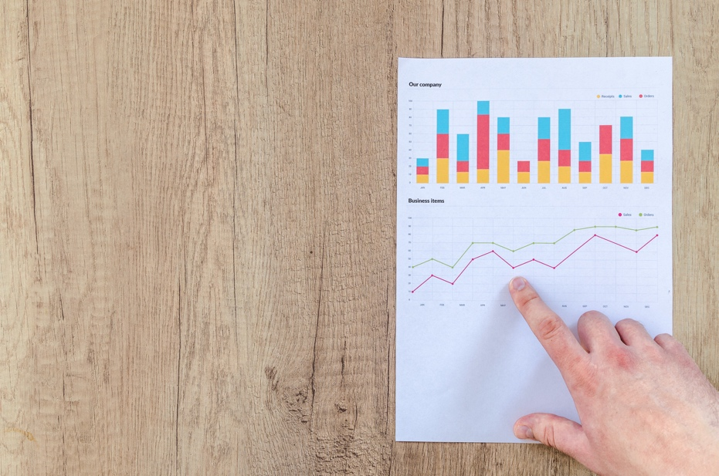

According to an article from 2020, there has been an increase in the health and fitness industry over the concerns about having a healthy lifestyle among the global population. Different industries are impacting this market for the health and fitness industry. People, especially from developed countries are taking measures to avoid critical health problems and conditions. (Business Wire, 2020). This tells us that there is a growing market for healthcare and fitness, and people are constantly looking for new applications to ease their process.

We have already mentioned how the Post Covid world has made people be health conscious and make wiser decisions in what they consume, both internally and externally. The Healthcare industry EBIDTA (net earnings) grew 5% Pre – COVID-19 years of 2017 to 2019 and remained same during 2020 and 2021. Its expected growth is at 6% Post – COVID-19 years from 2021 to 2025. If this growth is achieved, then it could add up to $31 billion in profits, without considering the other factors like inflation etc. (Mckinsey & Company, 2022). New Businesses in the healthcare industry have higher chances to be successful.

**Problem Description**



Recently, there has been so much awareness on being healthy and following a diet, maintaining good physical and mental health and a fit healthy lifestyle. Although it is crucial to take care of one's health, it can be very challenging to keep track of everything needed to do so. In our fast-paced society, where everyone’s busy with their personal and professional lives, it gets difficult to take a break and focus on self-care. This is what inspired us to develop an app that would enable users to keep tabs on what was happening inside their bodies.

In this technologically advanced society, everyone uses a mobile phone. Creating a mobile application would not only  make it accessible to a wide range of audience, but also give our app an edge in user usability because users are more accustomed to the technology.

There are multiple existing applications, which are in the food tracking/ healthcare system, but are not completely utilizing AI’s potential. We want our solution to be a comprehensive, one-shop stop place, to give a complete and co-related analysis between multiple applications, depending upon their goals, with the user interface being simple, easy to understand and to be used by different demographics and ranges of people.

This mobile application not only analyzes the user's meals but also serves as a journal of the foods consumed. We will continue to take and consider customer feedback and will make future updates and modifications in response. We intend to collaborate with a number of other dieticians, trainers, doctors, health coaches, and others to provide users with more personalized recommendations through building a community.

The application will also assist users' existing health coaches in keeping track of their food intakes. We would also like to include additional features such as a fitness monitor/tracker in addition to the nutrition analysis for an all-rounded experience.

**Solution Description**

Sampurn is an mHealth app which acts not only as a food journal but offers insights on nutritional content of the meals the user has had. The user is asked to set their goal on signup. We offer varied goals for people to choose from, example: Weightloss, General fitness, Skincare, monitoring chronic illnesses, etc. On signup, the users are also given a choice to share their body metrics like weight, height, gender (Male/Female/Non-binary), medical conditions (ideally EHRs would be used), the medications they’re on, their ethnicity, dietary restrictions, preference of diet and health tracker connection. They can choose to enter this information for accurate predictions/recommendations or skip it and still get ballpark estimates. We follow existing data privacy and regulations standards and are transparent when it comes to user information.

Based on different use cases, the app is going to ask users for different inputs. If the user wants to cook, they can scan their pantry and by image recognition, the app recognizes the items in the pantry and recommends healthy recipes based on the users’ preferences. If the user ordered food from online food ordering apps (door dash, etc.) we ask them to input the dish and the app which they ordered so that we can collect nutritional/calorie information using APIs from the app’s database. If the user had a snack and would like to journal it, they can do so by scanning the barcode on the wrapper. Finally, if the user has prepared a meal, they can scan the meal and using image processing and food processing software’s, the nutritional information of it is captured.

Since the app is integrated with the wearables, if any, the statistics on nutrition consumed and the upper limit on the intake get updated dynamically on the dashboard. Along with the food intake, the app also has a count on the water the user has consumed and gives out timely push notifications to hydrate. The whole experience is gamified to trigger the reward system in the user’s brain so that they keep up with their health. There are also additional features in the app which motivate users to collaborate with people, join or build communities of their own to persevere until they achieve their goals.

The app serves a wide demographic as health and nutrition is of equal importance for all the age groups. We focus on catering to young adults through middle aged demographic the most, as they can work

with mobile devices and are actively working towards betterment of their health. This is for people with hectic and busy lifestyle, people who are conscious about their skin/body or people who want to keep their chronic illness in check. They set goals and input their details and system generates ideal nutrition intake based on this which dynamically changes based on their activity levels.

One of the AI components of this AI Application is going to be the image recognition of the user’s inputs. There is another AI component of the AI application, which is going to connect the user’s input and search for the takeout restaurant’s menu from the third-party applications. We are including AI here as to make it easier for the user just to just click a picture instead of manually entering each component of the item. We are also further adding multiple features like a recommendation system for cooking and takeout based on user’s required portion/nutrition size, which helps user’s take conscious decisions. Other features like automatic scaling utensils for easier nutrition analysis, electric water bottles which records and reminds about the water intake, fitness trackers like smartwatches, smart keychains etc. All these features will come together in synchronization for an optimal end-to-end solution

The outputs of the solution are health charts, which can be used for real-time analysis. Based on the client and the use-case, they can be inputs to varied systems, like, nutri-care organizations or ideally used by dieticians/health coaches for reference. The users can also check these charts for their own understanding of the food intake.

**Solution Data Requirements**

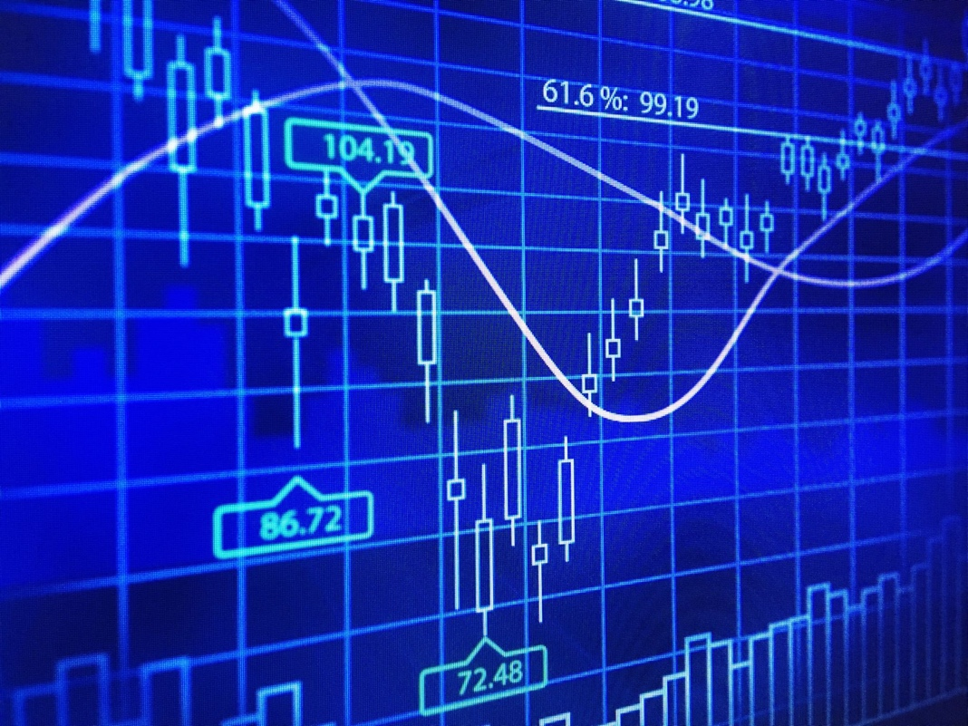

Since Computer vision is expensive, we at Sampurn would be using cloud API’s. Also, as the predictors are not dynamic or relatively static and don’t change a lot (pixels values of images), creating an inhouse solution wouldn’t make a lot of sense because personalization or customization is not expected. It is basically just an image classification problem and there are companies who have worked on it already and have solutions readily available to be leveraged, so we would be using their solution. Hence, we do not have to think about training data, we would be using pre-trained models in our case.

We expect users to input clear and well-lit pictures. For accurate analysis and classification, we caution users if the picture taken doesn’t meet minimum quality requirements. One of the other steps taken to make sure the quality requirements are meant are to train the model with a bunch of imperfect food images along with proper images. Finally, if the picture taken doesn’t meet minimum quality requirements, we give a ballpark estimate and ask the user to confirm if it’s true, so the user would have a chance to alter the estimated output.

Captured input data of both text and image vectors is made to pass through a data transformation pipeline (discussed with detail in the Solution Architecture section). It’s a necessary step to take, so that we get to an even playing field for all the inputs, for example, change the dimensions and make them equal, change the color model from CYMK to RGB etc. Equalizing the hue, saturation, brightness, exposure of the images, etc.

**Acquisition strategy / Platform requirements**



AI Cloud APIs -

The solution will be using Cloud API’S for connecting to external food delivery applications to provide users with the information as per their input.

Proprietary Algorithm -

We use CNN Algorithm, which is a feed forward Neural Network, is widely used in image classifying process and as image recognition is done on pixelated data. Convolution Layer places a filter on image pixels (like a sieve), which creates convolution features maps, which provides internal insights about the image. CNN can perceive patterns in data across space. Taking a proprietary algorithm for our problem is the best solution since our predictors are not dynamically changing.

Custom Algorithm -

We use a pre-existing proprietary algorithm instead of building our own as it makes better sense for us to use that for our solution.

**Underlying ML model requirements**



ML Based AI -

Our AI is ML based. We used Computer Vision and CNN Algorithms, which are a part of Deep Learning and Neural Networks, which is one of the approaches for Machine Learning. (Computer Vision vs. Machine Learning | How Do They Relate?, n.d.)

Role of the ML model -

The main role of ML in our solution is identifying the food components of the meal plate. We will be using a CNN Algorithm with training - test split of 70 - 30 % and our target  variable is going to be image detection and classification to differentiate different food items and components and provide complete user analysis. We have considered different instances of meal intake and one of them is going to be taking user input for dine out option to connect to third-party applications to get information about that meal using API’S.

Performance criteria -

Our problem is a classification problem so some of our model performance metrics are going to be on Accuracy, Misclassification Rate, Precision/ Recall rates. The Accuracy rate for the current food classification is 41.72%. It is discussed further in the Solution Architecture below.

**Solution Architecture**

We have divided the architecture into three phases:

1. Data sources or inputs
2. Data Processing
3. Output systems or end-users

Coming to the first phase, it consists of the data sources or inputs s the name suggests. The primary data source is going to be the user input both as images and text. We also have other data sources like OLTP systems which take in the company’s data to work with. External feeds like health trackers (Fitbit, etc.) are also present. Since one of the use-case uses data from another website/app, it does it using APIs, so it is taken as one of the data sources. Other streaming data can come in from Apache Kafka streaming services. Ideally, we would be taking in EMRs (Electronic Medical/Health Records) but it’s still under discussion as there are multiple data privacy restrictions. Our systems have all sorts of data coming in – structured (tables), unstructured (images) and semi structured (json) as seen from the figure. The inputs mostly use time-based triggers, the time duration for every trigger is ~10mins. The data is taken in every 10 mins from the data sources. This can be changed based on the costs.

Coming to the second phase, it’s the processing phase which will be discussed further. We decided to use Microsoft Azure as our cloud services provider because of the top-notch security that they offer. We store the integrated data (from all the data sources) in Cosmos DB NoSQL database. This data is then moved to the data lake house (Azure Synapse) based on the use case. The data then is pre-processed in this layer using Azure Databricks. It’s a necessary step to take, so that we get to an even playing field for all the inputs, for example, change the dimensions and make them equal, change the color model from CYMK (Cyan, Magenta, Yellow and Black) to RGB (Red, Green, Blue) etc. Equalizing the hue, saturation, brightness, exposure of the images, etc. Since computer vision is a problem which has been already solved by many companies and our problem is fundamentally and image recognition problem, since the predictors aren’t dynamically changing, it doesn’t make any sense to create an in-house solution, so we use Cognitive services, which is a cloud AI service provided by Azure.

Lastly, we further discuss about the output systems or end-users. Based on the client requirements, there are multiple output systems that the processed data can act as an input to. The processed data can be used for operational reporting and real-time analytics by the app for the user. This can also be used by Sampurn staff. Based on prospects or the sectors we plan to get into or the companies we collaborate with, this can be used by multiple nutri-care organizations or eventually by the hospitals (healthcare industry). The whole architecture, or all the components are a part of the data pipelines that we created and there’s nothing manual going on in the solution. It’s all automated.

**Code**

File:



The libraries like numpy are used for pre-processing the data. The path object from path library and os.path are used as well. Data visualizations are done using pyplot and seaborn. Train-test split function is used for pre-processing. The model is built with TensorFlow. Model’s performance is analyzed using confusion matrix and classification report.

Firstly, we create a data frame which has the list containing one column with all the path variables and the other column with all the labels with each image associated to the file path. Using this format, we can use the Keras data generator function. The train-test split is taken as 70% and 30% respectively. After the two sets of data are ready, we create generators because they are a feasible way of loading images one batch at a time, so the memory doesn’t run out. We use a pretrained model called “mobilenetv2” whose underlying algorithm is that of convolutional neural networks (CNN). SVMs could’ve been used for image recognition/classification but CNNs perform better and faster.

CNNs are feed forward neural networks and are best suited for spatial data and hence are widely used in image processing and natural language processing. In CNN, instead of neurons being connected to every neuron in the previous layer, they are only connected to neurons close to it and have the same (What is a convolutional neural network (CNN)? [Video], n.d.) weights assigned to them. There are two layers in between input and output (fully connected) layers, they are convolutional layer and pooling layer, which in our case uses relu (rectified linear unit) as activation function to ensure non-linearity of the input vectors. Convolutional layer places a filter on image pixels which creates a convolutional feature map. Pooling layer downsamples the size of particular feature maps, i.e., it reduces the parameters the network needs to process (can use max pooling or min pooling). It basically extracts features, and the network creates a picture as per its own mathematical rules. CNNs can perceive patterns in data across space.

Finally, the model is run with the given parameters and Model evaluate gives the loss function and accuracy of the model. The accuracy is about a 41.72% but can be increased by hyperparameter tuning etc. The precision, recall, f1 score, and other metrics are shown in the images of the output attached above.

Model Summary -

1. TensorFlow, Numpy for data pre-processing
2. Train-test split 70-30
3. Pretrained model “Mobilenetv2”
4. Underlying algorithm CNN (convolutional Neural Network)

**Prototype**

We have our App Flow Mock Prototype here -

[**App Flow**](https://www.figma.com/proto/CB3jJ7DQuaG4APG4eUrJP6/Untitled?node-id=1%3A2&scaling=scale-down&page-id=0%3A1&starting-point-node-id=1%3A2)

The app flow for Sampurn is created using the design tool Figma. Sampurn’s app design adheres to existing design standards. The main idea behind choosing Green as the primary color of the app’s color palette symbolizing something natural, organic and healthy. The app logo is an “S” in a green circle symbolizing completeness (circle).

The first screen designed is the usual signup/sign-in screen like all the other apps, where the user enters their email/phone number and password and signs up or uses facebook, google or apple to sign up. Next comes a series of screens which are one-time forms for setting user preferences, goals and retrieving as much information from the user as possible for accurate analysis and recommendations.

User can set their goals on the goal setting screen. Sampurn covers varied set of goals

(example: Skincare, Weight loss, Stress relief, etc.) for the user to choose from. User can also mention their own plan if they don’t want to select anything from the list mentioned. The next screen takes the user to body summary page, which asks the user their body metrics like age, height, weight etc. for accurate analysis. For uniformity, the units of inputs are mentioned as helper text in the input boxes. Since Sampurn stands for diversity and inclusion, we do not take the one size fits all approach, but give personalized analysis based on ethnicity and demographics (example: Indians could be more prone to CVDs because of high content of saturated fats in their diet), but it’s kept as optional for privacy issues.

The next screen sets the user’s diet preference. There are options like Keto mentioned but user can enter their own diet preference. Next comes the medical summary screen in the series. The user can mention any chronic illnesses they have so that Sampurn can give warnings or recommendations basing off the restrictions mentioned. These are supposed to be ideally retrieved from EMRs but that’s still in discussion. The next screen is a permission screen to connect your fitness tracker with Sampurn. The last two pages can be skipped for privacy reasons, we give you an option to skip them altogether. This one-time form can be altered at any time, i.e., the preferences can be altered at any time by going to the user setting section.

Finally, the user is taken to the dashboard where all the nutrition statistics for the user during different timelines is shown. It also shows the count of calories which are done for the day and the number left yet to be consumed. If the user connects their fitness tracker, the statistics from the tracker are also shown. There is also a section which can input the number of glasses of water the user has had during the day and gives out push notifications to hydrate. There are little gamification components present on the top header menu, under the welcome note. It is also color coded, if the user is active and it changes to green and says that they are on track, if the user is lagging, it changes to orange and ask the user to buckle up similarly if the user is completely inactive, it changes to red and warns user.

Now, we get to the main function, “Add Meal” which is the main floating button at the navigation menu towards the bottom. When the user clicks it, it shows 4 options. Cook, which can be used when the user wants to cook a meal; when the user clicks this, the camera of the phone is opened with user’s permission and the user is supposed to either scan their pantry or manually enter the ingredients that he has and our app gives recommendations on healthy food that they can prepare based on the preferences and calorie count remaining of the day. Order/takeout can be used when the user has ordered something from a third-party online food ordering service, they just have to plug in the name of the app, the restaurant and the dish ordered, and our APIs retrieve the calorie/nutrition data from the respective app and update them in Sampurn. Barcode, if the user has eaten a snack in between meals or a packed meal, they can scan the barcode and our app will retrieve nutritional data from it. Scan a meal, if the user has already prepared a meal, they can scan it with their phone’s camera and the nutritional data is retrieved from image recognition and food processing software (like ESHA, not finalized yet) and will ask for user’s confirmation if the recognized food is correct or not, if it is not, the user can manually enter the food items and we will calculate the nutrition.

On the navigation menu, the user can get to “Challenges” page which has fitness challenges posted by us every week. With a leaderboard and community forming exercises. One of our main goals is to connect people and motivate them to get fit together both mentally and physically. The journey of self-growth can get lonely, and we do not want our users to feel that they are alone in any way.

**References / Citations**

* (Insights into the Worldwide Health & Fitness Services Industry to 2025 - Mergers, Acquisitions, Agreements, and Collaborations - ResearchAndMarkets.com, 2020)
* (mHealth Apps Market Size, Share & Trends Analysis Report By Type (Fitness, Medical), By Region (North America, Europe, Asia Pacific, Latin America, Middle East & Africa), And Segment Forecasts, 2022 - 2030, n.d.)
* (The future of US healthcare: What’s next for the industry post-COVID-19, 2022)
* (MyPlate, n.d.)
* (Rx Food App: A Proof-of-Concept Study of an Image-Based Dietary Assessment Mobile Application, 2021)
* (Computer Vision vs. Machine Learning | How Do They Relate?, n.d.)
* (myfitnesspal, n.d.)
* (What is a convolutional neural network (CNN)? [Video], n.d.)
* [https://web-p-ebscohost-com.libproxy.library.unt.edu/ehost/detail/detail?vid=0&sid=4ea387f0-8439-49f5-b8ad-84e04686c384%40redis&bdata=JnNjb3BlPXNpdGU%3d#AN=143527454&db=bth](https://web-p-ebscohost-com.libproxy.library.unt.edu/ehost/detail/detail?vid=0&sid=4ea387f0-8439-49f5-b8ad-84e04686c384%40redis&bdata=JnNjb3BlPXNpdGU%3d)
* [https://web-p-ebscohost-com.libproxy.library.unt.edu/ehost/detail/detail?vid=0&sid=c5322501-6bd4-4bb6-a7ee-310bb5041463%40redis&bdata=JnNjb3BlPXNpdGU%3d#AN=137120578&db=bth](https://web-p-ebscohost-com.libproxy.library.unt.edu/ehost/detail/detail?vid=0&sid=c5322501-6bd4-4bb6-a7ee-310bb5041463%40redis&bdata=JnNjb3BlPXNpdGU%3d)
* <https://www2.deloitte.com/content/dam/Deloitte/us/Documents/deloitte-analytics/us-ai-institute-state-of-ai-fifth-edition.pdf>
* <https://www.stateof.ai/>
* [https://www.supercook.com/#/desktop](https://www.supercook.com/)
* <https://www.apple.com/ios/health/>
* <http://pic2recipe.csail.mit.edu/>
* <https://github.com/PhucDuy/MyKcal>
* <https://www.ibm.com/cloud/learn/api>
* <https://www.fitbit.com/hu/shop/zip>
* <https://blog.hubspot.com/marketing/write-value-proposition>
* [https://www.myfitnesspal.com](https://www.myfitnesspal.com/)
* <https://www.livestrong.com/myplate/>
* <https://ai.google/responsibilities/responsible-ai-practices/>
* <https://www.microsoft.com/en-us/ai/responsible-ai?activetab=pivot1:primaryr6>
* <https://www.microsoft.com/en-us/research/theme/fate/>
* <https://www2.deloitte.com/us/en/pages/deloitte-analytics/solutions/ethics-of-ai-framework.html?id=us:2ps:3gl:consem21:eng:cons:060820:nonem:na:6nXdXGco:1192109708:440322998826:e:Cognitive:Trustworthy_AI_Exact:nb>
* <https://www.apexofinnovation.com/mckinsey-on-leading-your-company-to-responsible-ai/>
* <https://www.ncbi.nlm.nih.gov/pmc/articles/PMC6543803/>
* <https://www.stitchdata.com/resources/oltp-vs-olap/>
* <https://www.narwalinc.com/services-data-warehousing>
* <https://dribbble.com/shots/18370023-Macro-Calorie-Counter-Mobile-App>